**Prerequisite**

**Create a database “TicketTracker_db” in mysql**

**Userid : root**

**Password : root**

**Tools :** **It works well with Chrome browser**

**Test #1**

Go to browser address bar type in the following

Localhost:8080

Application opens up as below

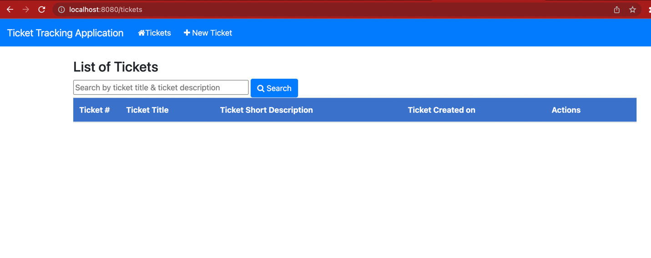

**Test#2(a)**

Click on the New Ticket on the menu bar ()

It opens up the screen “New Ticket” to enter details as below

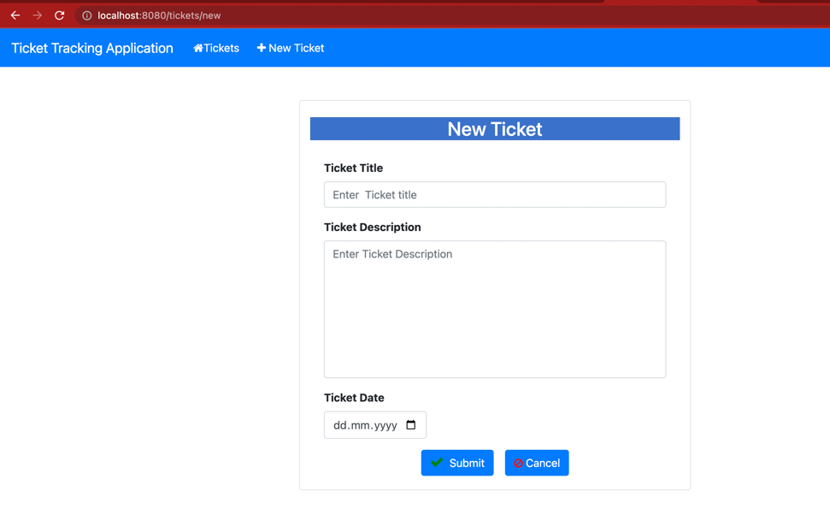

**Test#2(b)**

Enter the following details

Ticket title : OS problem

Ticket Description : Re-install windows 11

Ticket Date : 20.04.2023

Click on the submit button to store it into the database.

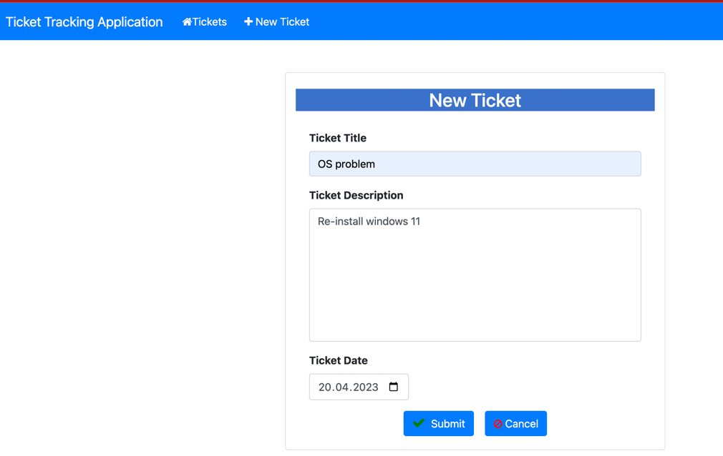

After submitting, opens up the home screen with list of ticket. The new ticket can be seen in the list.

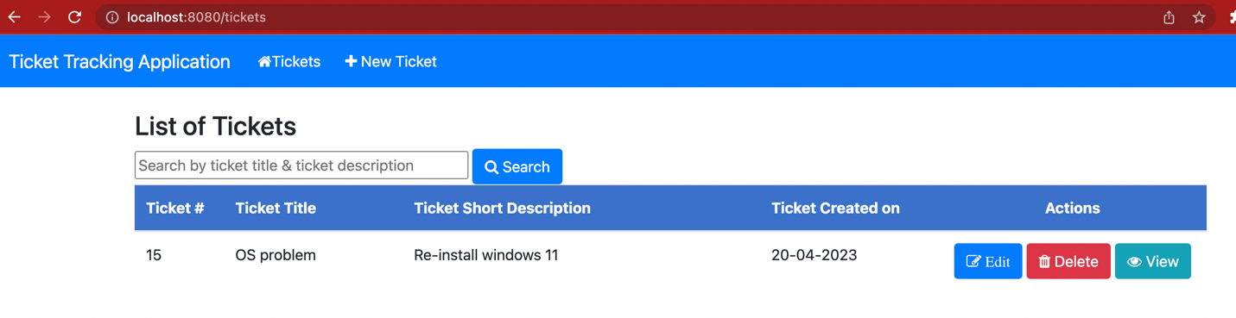

**Result**

The record is stored in ticket table

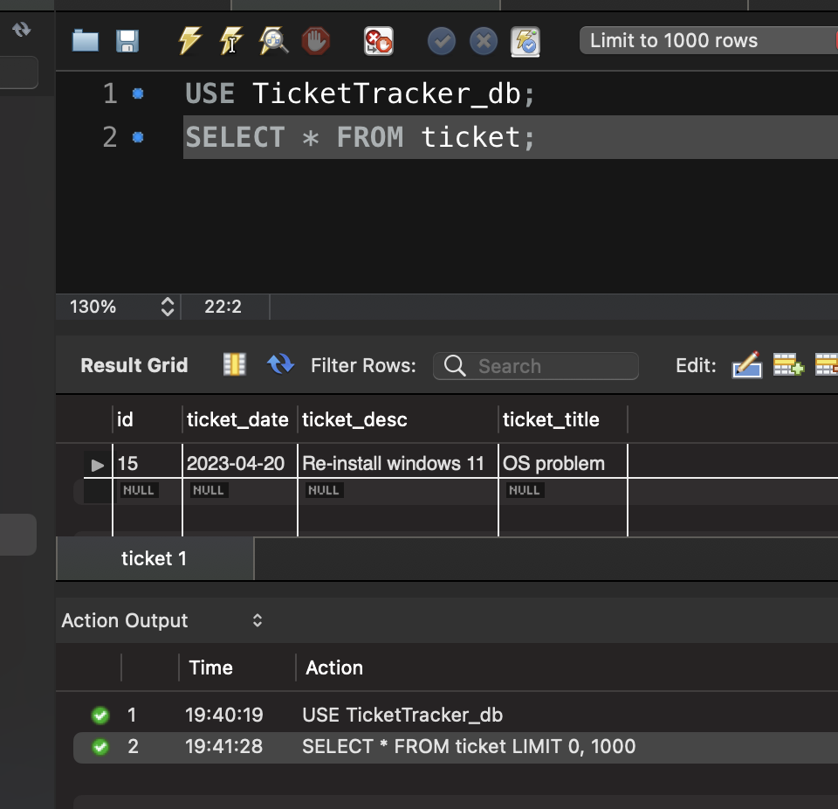

**Test#2(c)**

Now click on the Edit button ,

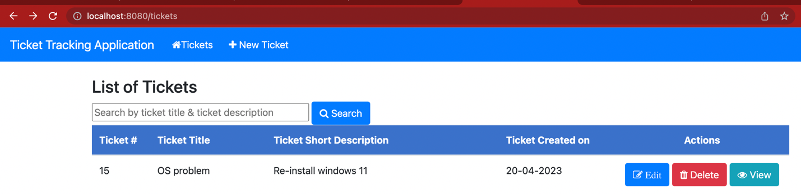

it opens up the edit screen as below

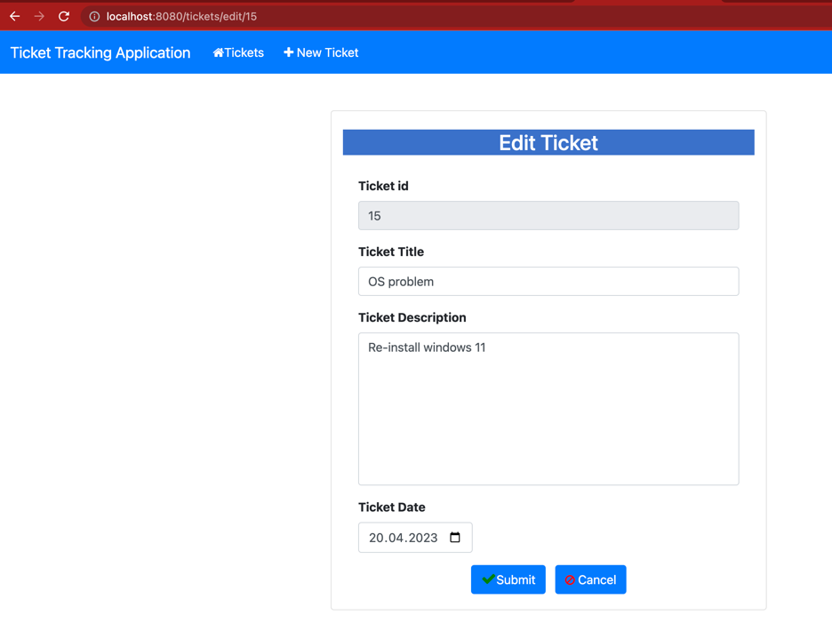

Ticket id is non-editable, only Ticket title ,Ticket description Ticket dates are allowed to edit.

Modify the changes as shown below and then click on the submit button

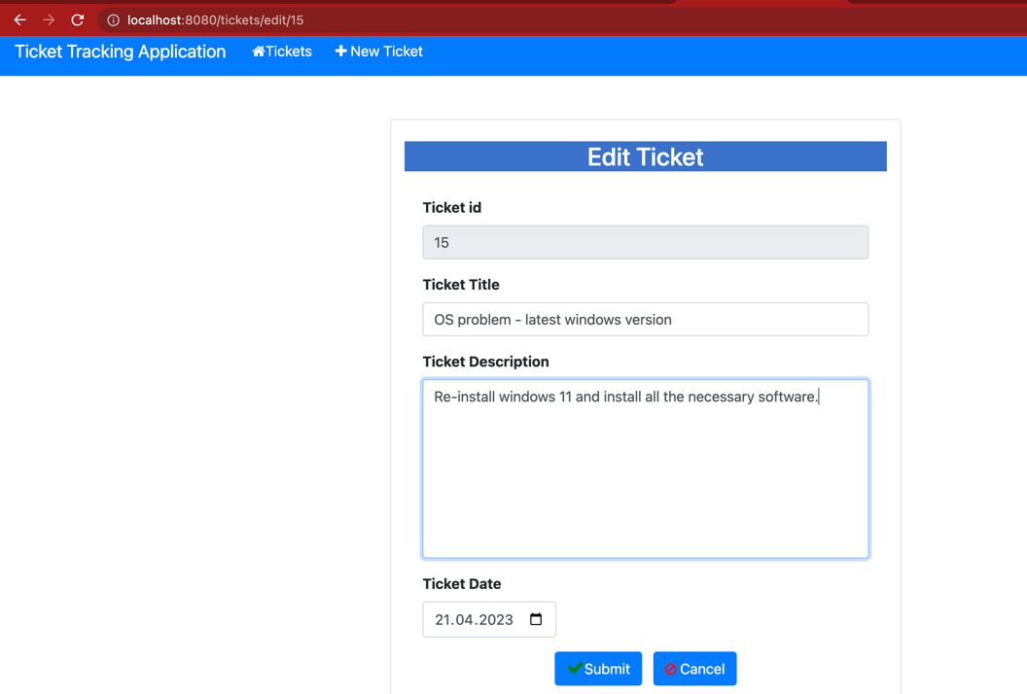

It goes to home screen with list of tickets and it shows updated value.

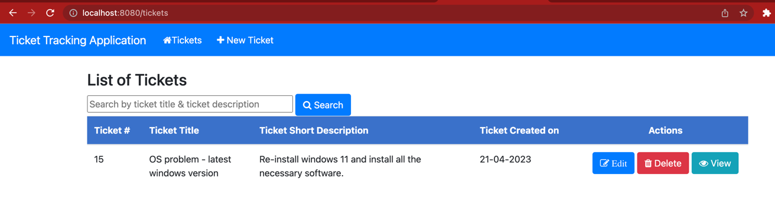

Checking Database

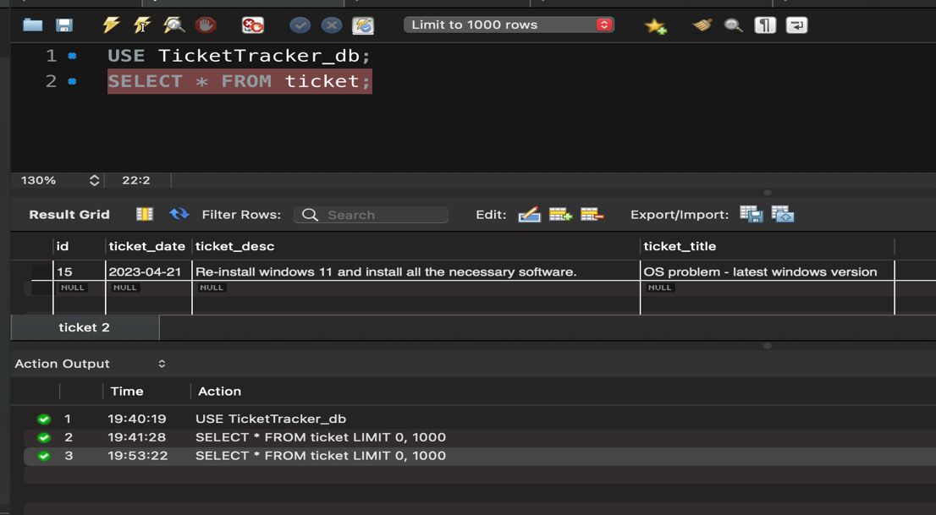

**Test#3:** Click on the View button 

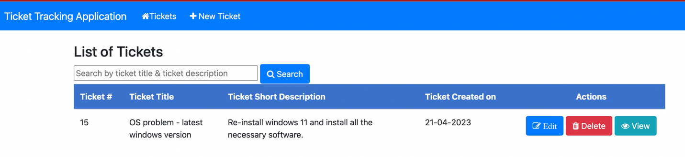

It opens View Ticket screen as below, all the fields are for view only and it cannot edited.

The updated value can be seen in the view screen.

**Result:**

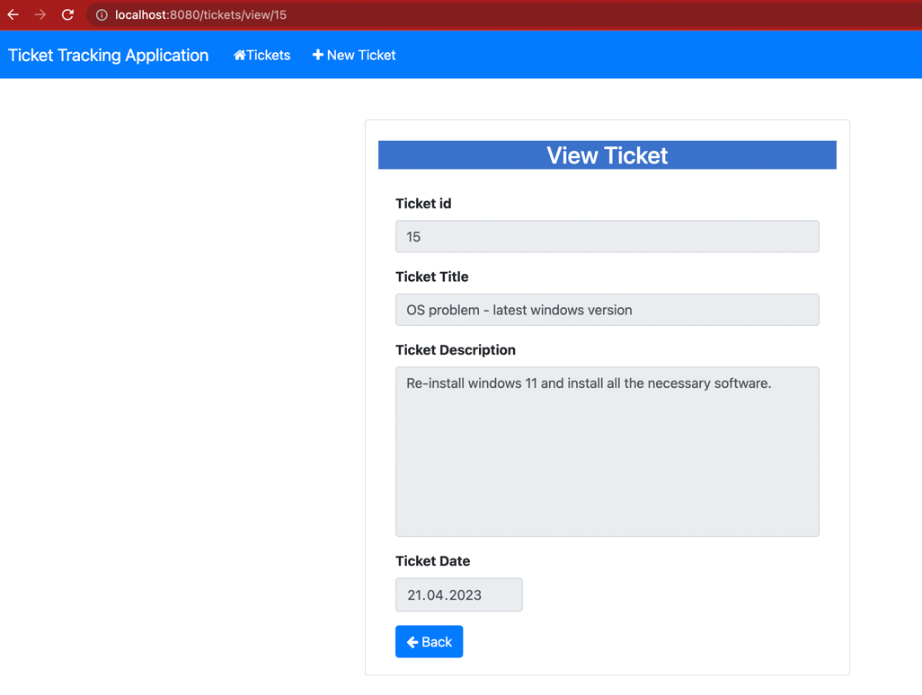

Click on the back button , it will go back to the homepage

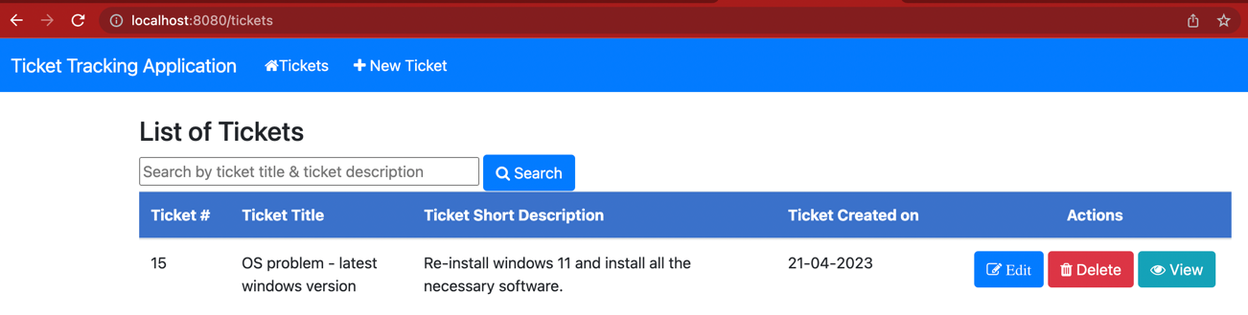

**Test#4**

Click on the Delete button  the record is removed from the ticket listing

**Result**

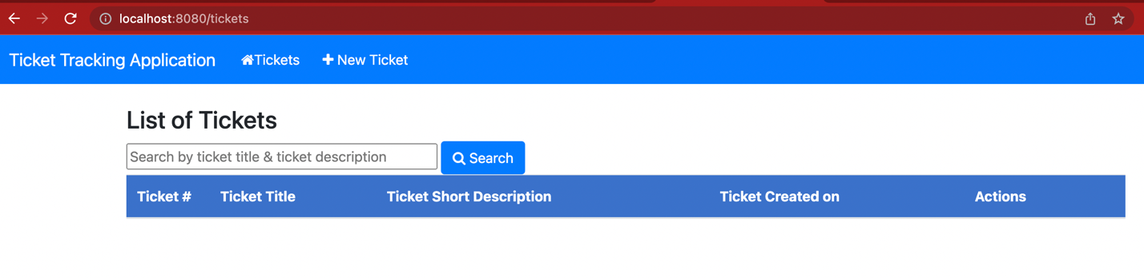

**Database check**

The ticke no#15 is removed from the table.

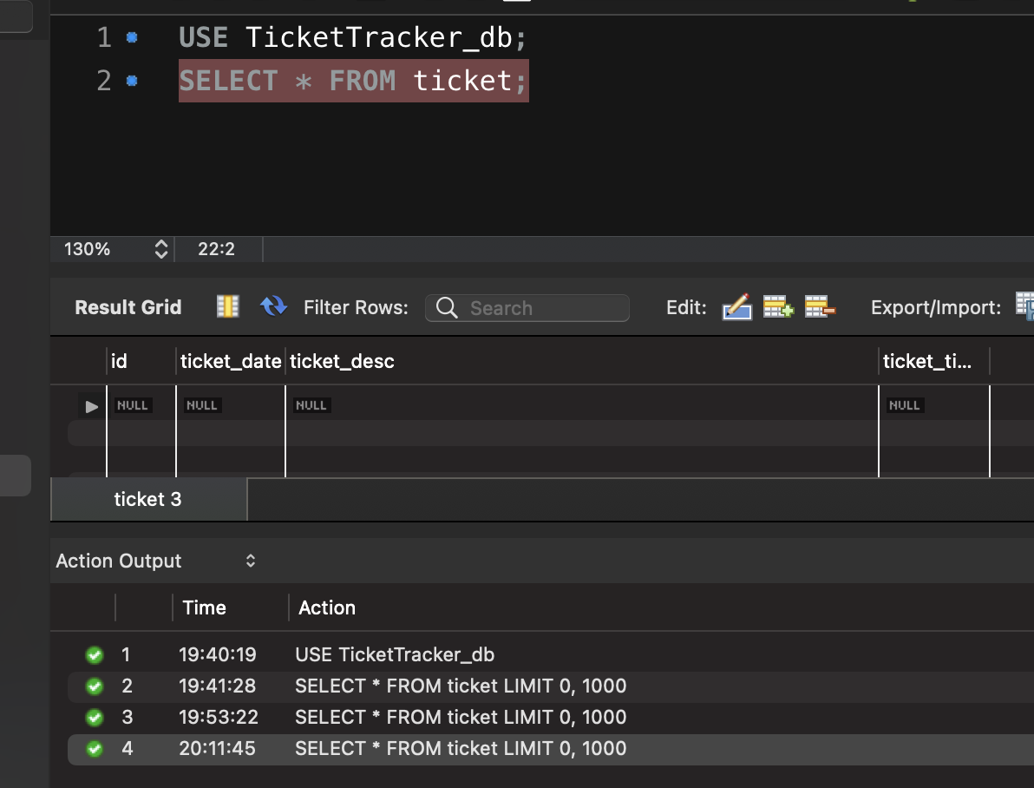

**Testing #5**

The following tickets are added to the system in order to test search functionality based on ticket title and ticket description.

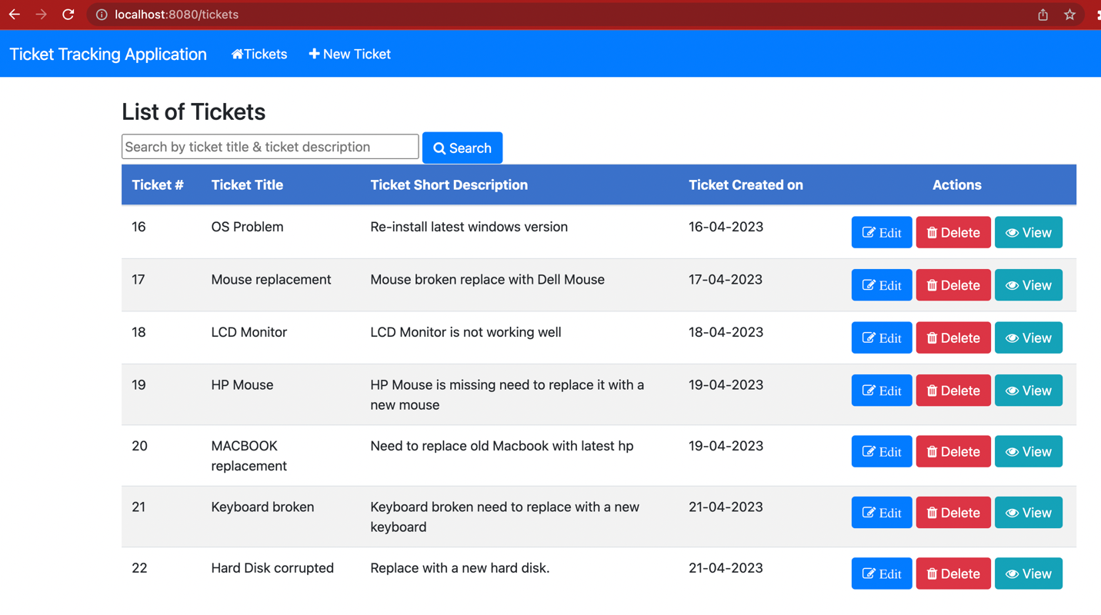

**Testing 5(a)**

Type in Monitor in the search box and click on search button

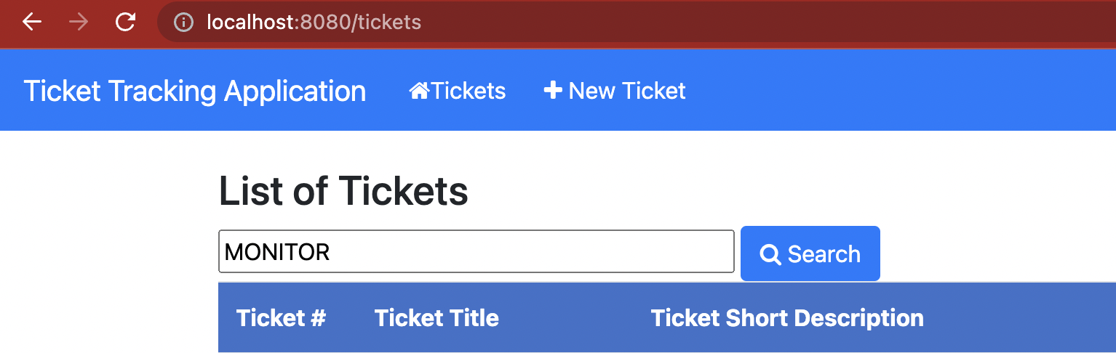

**Result**

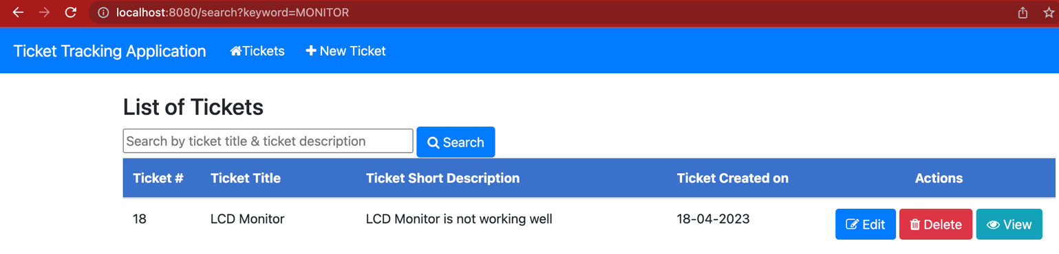

**Testing 5(b)**

Type in ‘**replace’** in the search box and click on search button

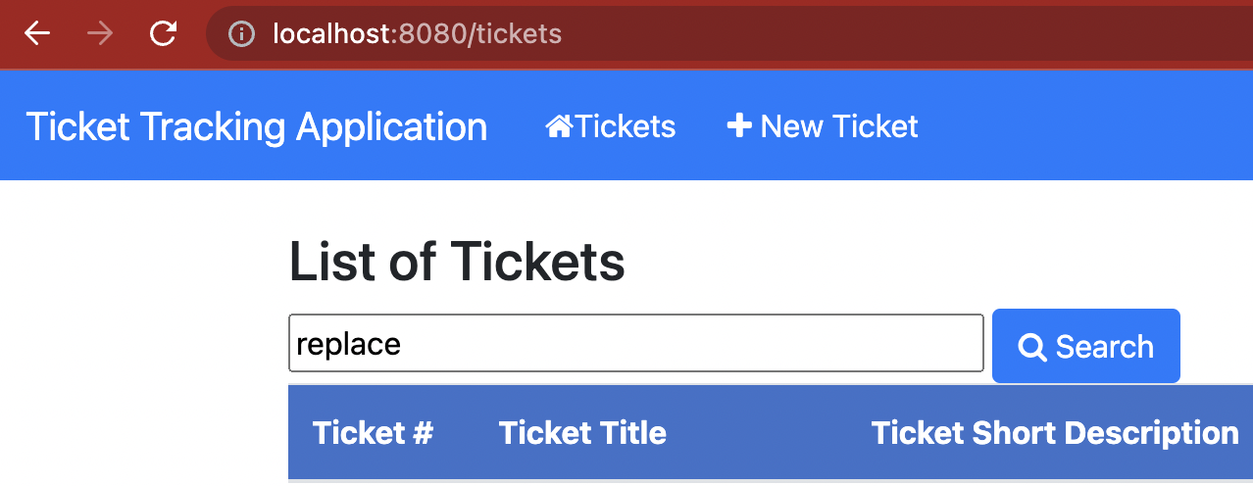

**Result**

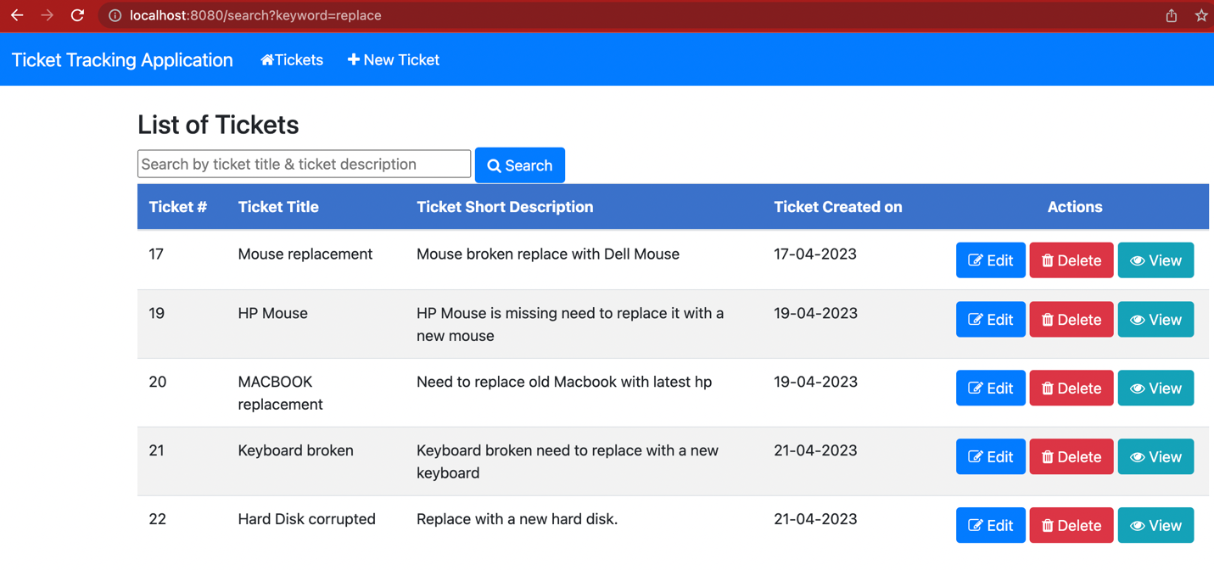

**Testing# 5(c)**

Type in **‘OS Problem’** in the search box and click on search button

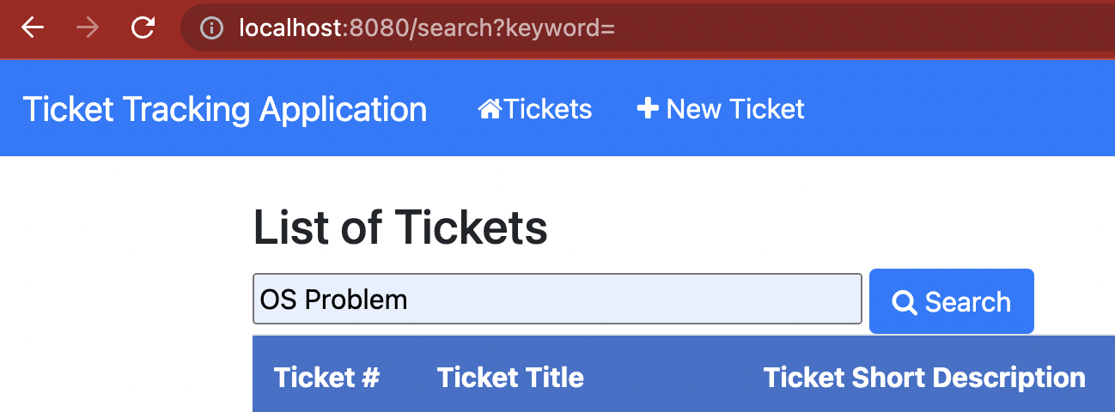

**Result**

